What Is the Imperative Mood? (with Examples)

Imperative Mood
The imperative mood is a verb form that gives a command. For example:
- Empty the bin, John.
- John empties the bin.
Commands can include orders, requests, advice, instructions, and warnings.
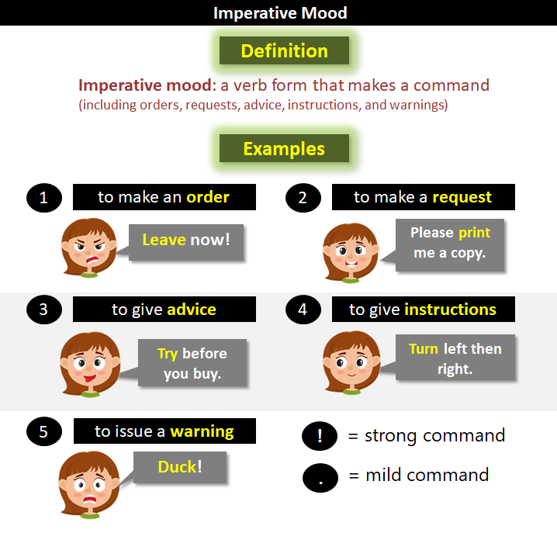
The main verb (i.e., the finite verb) in an imperative sentence (i.e., one that makes a command) is said to be in the "imperative mood."

Forming the Imperative Mood
In English, the imperative mood uses the bare infinitive form (i.e., the version without "to").
Example 1:
- Infinitive form: to take
- Bare infinitive form: to take
- Verb in the imperative mood: Take a leaflet.
Example 2:
- Infinitive form: to remind
- Bare infinitive form: to remind
- Verb in the imperative mood: Next time I see you, remind me not to talk to you. (Comedian Groucho Marx)
Example 3:
- Infinitive form: to do
- Bare infinitive form: to do
- Verb in the imperative mood: If you've heard this story before, do not stop me, because I'd like to hear it again. (Groucho Marx)

Examples of Verbs in the Imperative Mood
Here are some more examples of verbs in the imperative mood (shaded):
- Run!
- Get out!
- Stop the bleeding.
- I am going to cross the field. Shout when you see the bull.
(I am going is the indicative mood (i.e., just a statement). However, shout is in the imperative mood.)

What Is Mood?
Mood is the form a verb takes to show how it is to be regarded (e.g., as a fact, a command, a wish, an uncertainty).
There are three major moods in English:
- The Indicative Mood. This states facts or asks questions. For example:
  - I am painting the fence.
  - Are you painting the fence?
- The Imperative Mood. This expresses a command or a request. For example:
  - Paint the fence!
  - Please paint the fence.
- The Subjunctive Mood. This shows a wish or doubt. For example:
  - I suggest that Mark paint the fence.
  - I propose that Mark be made to paint the fence.
  - If I were there, I would paint the fence.

Why Should I Care about the Imperative Mood?
Forming verbs in the imperative mood causes native English speakers few mistakes. That said, here are two noteworthy points related to the imperative mood.

(Point 1) Don't use "myself" with a verb in the imperative mood.
This is a common mistake, especially in work emails.
- Please contact your manager or myself with any suggestions.
(It should be "me" not "myself.")
The subject of a verb in the imperative mood is an implied "you" (either singular or plural). This means you can only pair your verb with "yourself" or "yourselves." You cannot pair your imperative verb with "myself."
Read more about misusing "myself" on the page about reflexive pronouns.

(Point 2) Exclamation marks are easily misinterpreted.
When writing a command, be mindful of how much force an exclamation mark adds and how that exclamation mark could be misinterpreted.
- Pick me up at seven o'clock.
(This is neutral.)
- Pick me up at seven o'clock!
(This is forceful. Does it mean "exactly seven o'clock" or does it mean "don't forget!")
Never use more than one exclamation mark! It's considered crass.
Read more about exclamation marks.

Key Points
- You can only pair your imperative verb with "yourself" or "yourselves."
  - Help yourself.
  - Talk among yourselves.
  - Please email Jason or myself.
(Should be "me.")
- Never use more than one exclamation mark.

